Information technology in construction:
domain definition and research issues

Bo-Christer Björk

Orginially published in

International Journal of Computer Integrated Design And Construction, SETO, London
Volume 1, Issue 1, May 1999 pp. 1-16

This version contains the same text and figures as the Journal paper, but the layout differs.

Abstract
This article discusses the scope of research on the application of information technology in construction (ITC). A model of the information and material activities which together constitute the construction process is presented, using the IDEF0 activity modelling methodology. Information technology is defined to include all kinds of technology used for the storage, transfer and manipulation of information, thus also including devices such as copying machines, faxes and mobile phones. Using the model the domain of ITC research is defined as the use of information technology to facilitate and re-engineer the information process component of construction. Developments during the last decades in IT use in construction is discussed against a background of a simplified model of generic information processing tasks.
The scope of ITC is compared with the scopes of research in related areas such as design methodology, construction management and facilities management. Health care is proposed as an interesting alternative (to the often used car manufacturing industry), as an IT application domain to compare with. Some of the key areas of ITC research in recent years; expert systems, company IT strategies, and product modelling are shortly discussed.
The article finishes with a short discussion of the problems of applying standard scientific methodology in ITC research, in particular in product model research.

Key Words: Information technology, construction, research, integration, methodology

Introduction

Information technology in construction - a young field of research
The study of information technology applications in construction is a young field of research, still struggling to define its place within the large family of academic disciplines. Being a young branch of science, information technology in constructionΨ (for which the abbreviation ITC will be used in the following text) lacks a solid methodological foundation. This is in contrast to some older engineering disciplines which are based on basic sciences such as physics and mathematics, and where testing can be carried out in systematic fashion in laboratory conditions. The only paradigm that most researchers in the ITC domain currently share seems to be ”object-orientation”, a term which can be given many shades of meaning, depending of the context. Other than that there is a multitude of different research directions ranging from computer programming to management strategies. Practitioners and researchers alike are offered a wide range of IT techniques and management philosophies, many of which claim to be the ideal solution to the industry’s problems. Current and recent buzz-words include knowledge-based systems, product data technology, the Internet, EDI, as well as concurrent engineering, lean construction, business process reengineering, total quality management, supply-chain management and just-in-time production.
There is consequently an urgent need for some consensus on what the domain of study of ITC is (other researchers who have discussed the issue include Fenves [] and Brandon et al. []). Additionally, some generally accepted guidelines for how researchers can prove their "hypotheses" are needed. Some of the standard scientific techniques which all doctoral students are supposed to learn as a part of the training (i.e. replicability of experiments based on the information given in a thesis or paper, statistical basis for proofs of the validity of models), are rarely rigorously applied in much of the reported ITC research.
It is difficult to give a very precise definition of the domain of ITC and to draw crystal clear boundaries between ITC and nearly related research domains. Often the discussion of IT technologies of interest to construction is centred on the most recent tools that general developments in commercial IT or in Computer science research have to offer (a "technology push" viewpoint). Good examples are object-orientation, world wide web, expert systems. A contrasting viewpoint would be to study the information management process in construction in a comprehensive way and to identify potential application areas for IT tools (a "problem driven" approach).

Options for defining the domain of ITC
In principle, there are thus at least two options for defining the domain in a systematic way; a bottom-up bibliographical analysis of what researchers are actually doing or a top-down analysis based on some model of information management in construction. According to the first option it would be possible to provide a "map" of ITC research through a bibliographical analysis of the topics covered in the papers to be found in the leading ITC journals and conference proceedings, or by studying the contents of some databases of research projects in the domain (i.e. the SCENIC database []). There are probably a few hundred researchers world-wide who are active within this field. Implicitly they have classified themselves as belonging in this field by submitting their articles to the half-dozen journals which explicitly deal with ITC topics (i.e. ASCE Journal of Computing in Civil Engineering [], Automation in Construction [], International Journal of Construction Information Technology [], Electronic Journal of Information Technology in Construction [], International Journal of Computer-Integrated Design and Construction [], Micro-computers in Civil Engineering) or by attending the limited number of annual conferences in the domain. Such a bibliographical analysis could be carried out with a moderate effort. Probably a few topics (i.e. expert systems, product modelling and recently web technology) would stand out in such an analysis. The drawback is that areas of application of IT in construction, which in practice are quite important, would be poorly represented since researchers have been relatively uninterested in them (for example Document management, EDI).
In this paper the second option, using a highly abstracted model of information management in construction as the basis for a definition, is used. In order to arrive at such as model we first need a clear understanding of what we mean by ”information technology” and ”construction” and of the relationship between these two.

Definitions of “Construction” and “Information Technology”
It seems appropriate to start with construction since this is the fundamental activity to which IT techniques are applied. The purpose of construction activities is to produce artefacts such as buildings, process plants, roads and bridges. Civil engineering artefacts are, in contrast to most other manufactured products, located in particular places and need to be constructed on-site rather than in factories. They are also usually one-of-a-kind products. The duration of a construction project is usually long. A comprehensive definition of the construction process should clearly include the whole life-cycle of civil engineering artefacts, including both design, construction, operation and maintenance. In particular, it is important to stress the inclusion of operation and maintenance since an important part of the information used during these stages originates during design and construction. It is also important to include the manufacturing of the building materials needed as well as public planning and inspection activities, activities which often are overlooked in process models of construction.
Information technology (IT) can be defined as the use of electronic machines and programs for the processing, storage, transfer and presentation of information. In earlier days, when the emphasis was on processing the term electronic data processing, EDP, was common. Nowadays the use of information technology is no longer confined to huge number-crunching machines housed in air-conditioned computer halls but permeates all aspects of everyday life. Communications technology is today an important part of IT. Not only computers and their software, but also devices such as the telephone, the photocopying machine and the telefax should thus be included in our definition of information technology. Many of the functions of these devices are in fact increasingly integrated. With the latest generation of laptop computers it is already possible to send and receive faxes and emails. Recently, mobile phones which incorporate small microcomputers have started to appear on the market.

A simplified model of the construction process

The construction process: two interacting subprocesses
In the following the IDEF0 modelling technique[] is used in some of the figures. IDEF0 is not the ideal modelling tool for this purpose, but despite some deficiencies and limitations it is easy to understand and there are good computer-based modelling tools available. An IDEF0 model consists of a number of boxes representing activities. Each activity takes some inputs (such as information, raw materials, etc.) and transforms these into outputs (information, buildings and products). An activity is performed by actors with the help of machines, computer software, etc. The latter are called mechanisms and are shown as arrows underneath the activity box. An activity is on a more abstract level controlled by instructions or more general knowledge (controls).
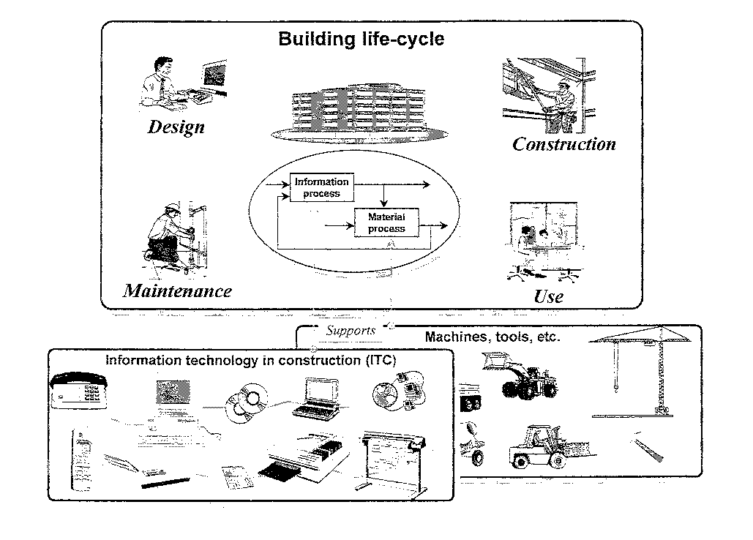
In a highly abstract way the construction process can be divided into two highly integrated sub-processes which interact with each other at many different levels. This subdivision is based on the nature of the objects that these sub-processes deal with. The information sub-process activities always result in information whereas the material sub-process activities produce services of physical objects (figure 1).

Figure 1. The construction process seen as two interacting sub-processes

In the material process raw materials and prefabricated components are created, modified, moved and installed and finally become embedded parts of the finished artefact. If we were to film a construction site during its whole duration, and to show it in extreme ”fast-motion”, what we would observe is almost exclusively the material process.
But the material process cannot function on its own. In contrast to the physical or chemical processes occurring in nature, the creation of any man-made artefact requires an information process which initiates and controls the necessary material activities. The immediate results of the information process are presented as drawings, specifications, schedules, procurement orders, etc. which control all material activities either by specifying the resulting artefact (design information) or the activities that need to be carried out in order for the artefact to be constructed (management information).
Both types of activities utilise resources which are consumed in the process (materials, energy, labour, wear and depreciation of machinery). The cost of an activity is the direct result of the consumption of resources. A special type of resource or input is information, which as such is not consumed in the process of using it, but nevertheless has a price.
The information and material sub-processes are integrated by information flows in two directions. Firstly, the information process produces information which indirectly or directly controls the material activities taking place. Secondly the information processing activities constantly need feedback information about what is actually happening in the material process, in order to check compliance with the designs or monitor the progress of the work against the schedules. In a longer time perspective the information process also needs feedback on the performance of buildings during the maintenance stages.
The interface between control information and actions in the physical world is consequently of interest. On one hand, information needs to be transformed into actions carried out by persons or by persons aided by tools and machines. The extreme case is the use of robotics, where information on higher levels needs to be transformed into very detailed instruction for how the robot moves its arms. Going in the other direction, physical impulses such as temperatures, pressures, light, etc. need to be transformed into information using measurement equipment. The simplest transformation is done by the human eye and brain by visual observation. This mechanism can today in many cases be substituted by IT-enabled techniques such as bar code readers and automatic pattern recognition.

Levels of abstraction in the model
This clear split into information and material process activities can be observed on several levels of abstraction. On the highest level in our schematic model we can envisage the whole construction process, say from inception to the delivery and use of the finished artefact, which consists of a higher part aggregating the set of all information processing activities and a lower part containing all material handling activities.
If we look at the process slightly more in detail we will notice that the information process includes several consecutive and parallel activities even before any material activities start. Stages such as briefing, schematic design, tendering, etc. are basically only information processing activities and it is only in the later stages of the construction process that there is a close correspondence between information and material activities, in the sense that the information process results in detailed instructions which control material activities. The end results from an earlier information processing activity are used as input information to the next activity (for instance, the client’s brief as input to the schematic design stage, and the architect’s designs as the basis for structural and building services design). In addition to product and process definition activities, analysis activities which aim at predicting aspects of the material process during construction or operation of the facility (i.e. cost estimation, energy simulation, FEM-analysis) are typical in these early stages.
In later life-cycle stages, we find that the information activities start to result in information which more directly is used to control the material process, such as the procurement of materials and the construction activities on site.
At some point of detailing in our hierarchical model (i.e. weekly or daily planning of on-site activities) a stage is reached where the formalised, often company-specific documentation routines end and where oral communication starts. Much of the detailed information processing is left to the individual workers actually carrying out the tasks. This does not mean that the information process ends, the basic abstraction is still valid, but that at this level of detailing formal documents are no longer produced. A human bricklayer for instance does not require as detailed instructions as a robot doing the same job would.
An important trend of the last hundred years or so is, nevertheless, that more and more of the information needed is explicitly formulated in project documents, master specifications, etc. In earlier centuries much of the information was conveyed orally and there was heavy reliance on craftsmanship. Part of this increased degree of formalisation could also be explained by the more and complicated building services systems which need to be documented, but for the most part the underlying reason seems to be the increased division of labour in the construction industry.
The subdivision into material and information activities has been discussed quite at length above. One reason for this is that this way of describing the process differs somewhat from the mainstream of construction process modelling efforts [], []. In many of the descriptions found in the literature, the modelling tends more to follow existing organisational borders and current documentation practise. In such models the design phases are clearly distinguished, but it is difficult to separate out the information handling activities involved in site construction and the procurement of materials. One author who, nevertheless, has discussed a similar distinction to the one presented above is Tolman [].

Trends in the use of machines in construction
In a historical perspective, the construction industry shows an increasing trend to use machines to automate both the material and the information processing activities (Figure 2). Since the industrial revolution started in the 18th century, machines have been used to automate or to aid man in performing material handling tasks. Tremendous increases in productivity have been achieved in particular in the large scale movement of materials typical of infrastructure projects.
Since the latter half of the 20th century machines have increasingly been used also to aid in information processing tasks. Early uses were in particular computer applications for engineering analysis. Since the 1980's IT use, in the form of CAD and word processing software, copying machines, faxes, mobile phones, computer networks, etc. has increased enormously and now affects all aspects of the information process.

Figure 2. Information and materials activities are supported by their respective machines and tools

There are two different ways of using machines for automating activities (or for aiding humans in performing them). The first one is to take the manual process as it stands and use machines or computers to enhance it (straightforward automation). The second option is to redesign the process, taking into account the possibilities offered by machines (re-engineering).
A good example of straightforward automation is the use of a CAD-draughting program instead of a drawing board for the production of construction drawings. A CAD-system certainly offers some productivity gains compared to the traditional process, in particular for managing changes or if repetitive drawing elements are used. The end result is, nevertheless, almost exactly the same as in manual drafting and often the resulting drawings are copied and mailed just like before.
An example of re-engineering is provided by the way the Swedish facilities management company ABB Fastigheter uses IT to enable service personnel to handle complaints and malfunctions related to the thermal comfort and energy usage in their large building stock. The service personnel are contacted through their mobile phones. Instead of rather expensive travel to correct situations, in particular during weekends and in the sparsely populated northern parts of Sweden, they access the computerised control system of the building in question over a modem from their laptop computers and make any necessary adjustments remotely. This leads to substantial reductions in the amount of personnel and travel needed and also makes the work itself more comfortable.
IT has, in the initial stages of its introduction in the construction industry, mostly been used for straightforward automation. Only after a number of years have enterprises learnt about the opportunities offered by IT and started to use IT in more innovative ways. The recent developments in networking and communications technology and the miniaturisation of the hardware have also started to offer increasingly possibilities for re-engineering.

Generic information processing activities
In order to better understand the history of the introduction of IT in construction we can further refine the information part of the above model. In our model all activities of the information process which directly produce new information or change old information can be considered primary activities. Sometimes such activities can be carried out in relative isolation by individuals, using only their skill and knowledge as well as the computational tools directly at hand. The creative work of many major architects may belong to this category. In most cases there is, however, need for some degree of consultation with other persons or the use of input or background information which has been created and stored earlier. Thus, the primary activities which produce new information are almost as a rule supported by secondary activities such as communicating with other persons or retrieving background information. We can consequently distinguish the following types of generic activities:
- Creation of new information
- Person-to-person communication
- Information search and retrieval
- Information distribution
The interrelationships between these are shown in the following IDEF0-diagram (Figure 3). Note that communication and information search activities are usually triggered within information creation activities to provide required inputs, whereas information distribution is applied to the outputs of the “create information” activities.

Figure 3. Four generic information process activities and their interactions

Details of this model are discussed more fully in a recent conference paper [], and work is on-going to further develop the model. A similar related model has been proposed by Turk []. What is useful in this context is to use this diagram as a basis for discussing the development history of construction computing.
The choice of these four categories is, to some degree, a matter of choice and could be criticised. The main reason for these particular subtypes is that it is relatively easy to group the application domains of general IT techniques using this classification. Thus a word processor is mainly used for the creation of new information, data base systems are tools for information search and retrieval, computer networks facilitate the distribution and retrieval of information and mobile phones aid in person-to-person communication.
The split into these four types of activities is evident only only as we study the information process in its details. At a higher level of abstraction, aggregated activities (for instance a task such as detailed architectural design) are found which in themselves consist of huge numbers of individual tasks belonging to the four categories above. In Figure 4, which tries to illustrate the decomposition hierarchy of a construction project, these four generic activities can be found on the subtask level.

Figure 4. A decomposition hierarchy for information and material activities in the construction process.

The design of the overall layout of a building, for instance, is a typical aggregated activity, consisting of a large number of sub-activities from all the above categories. In addition to the actual primary decision-making activity resulting in the layout design, supporting activities such as the retrieval of the city plans needed as a basis for the decision-making are needed. Communication in the form of meetings between the different designers, sending faxes to the client, etc. is also needed in order to achieve this task. At the end of the process the resulting design solutions have to be distributed to other parties using plotters, copying services, the WWW, etc.
An analogy from the material process would be the casting of concrete, which can be considered a primary activity since its result will directly be incorporated in the final product. The transportation of the needed materials to the site is a necessary support activity comparable to the retrieval of information.

The introduction of IT in construction from a historical perspective
During the early decades, IT was almost exclusively used to support activities which could be categorised as creation of new information. Analysis programs for structural analysis and other similar applications relied on tedious manual preparation of input data (e.g. in the form of punched cards). During the early 1980'ies the use of CAD started to proliferate, but still the emphasis was on support for the creation (and the viewing) of data. The support for communication was limited to several persons being able to sit by a screen and view the same image during a design session, whereas the support for information retrieval consisted in several terminals being connected to the same dedicated super-mini on which the CAD software was running. Support for making information available came in the form of very expensive A1/A0 plotters, which enabled the plotting of drawings which emulated manually produced drawings and were sent to copying services before the actual distribution.
This state-of-affairs is in fact the explanation for why early CAD use never achieved the huge productivity gains that the vendors promised. The efficiency of drawing production (especially in connection with changes) increased at best by a factor of 2-3. But real-life designers only use a couple of hours per day doing very concentrated drawing production work, the rest of the time is occupied with information retrieval, communication with co-workers, creative pauses, etc. In the early years there was hardly any IT support for retrieval and communication tasks. Nowadays the situation has changed dramatically. Developments in LAN and WAN networks, the Internet, mobile phones, video-conferencing etc. has extended IT support to a much more comprehensive coverage of the communication and information retrieval activities shown in figure 3. This is also reflected in the topics treated in construction computing conference papers and journal articles.
It is interesting to note that some of the most important effects of IT on the business processes in the industry have happened more or less in an unplanned fashion and not through conscious re-engineering or preceded by extensive research. Consider for instance the rapid proliferation of the telefax. How many scientific articles have been written about the effects of the telefax on communication and business processes in construction?

The domain of ITC research

Primary topics of ITC research
Against this background, what is the domain of study of information technology in construction? How does ITC differ from closely related disciplines such as design methodology, construction management or facilities management? In the following some suggestions are presented.
ITC is concerned with the information process. It is also concerned with the interfaces between the information and material processes (techniques for data capture and automatic control). It is, however, only indirectly interested in the material process, through the possible effects that a more efficient information process can have on the material process. In this respect it differs from construction management, which has a much more direct interest in the material process.
Furthermore ITC is in particular concerned with how IT tools and techniques can be used to facilitate and re-engineer the information process. Design methodology is also interested in how information is created and managed but the use of IT tools to support design activities is only a secondary issue.
ITC research is more concerned with the generic problems of how to apply new evolving IT techniques to construction problems than with problems related to particular types of artefacts, limited phases of the process, etc.. During the latter half of the 1980’s there were for instance numerous conference papers and articles on prototype expert systems for solving various problems in design, construction and maintenance. The more generic results concerning knowledge elicitation, applicability of different types of expert systems techniques and comparisons of the results with the judgement of human experts were in this author’s opinion in general more valuable for advancing the scientific knowledge of ITC than the exact knowledge bases which were developed.
Similarly, it is useful to draw some kind of borderline between “mainstream” ITC research and the development of computational methods for engineering analysis. Techniques such as FEM-analysis of structures or energy simulation of buildings rely entirely on the use of computers, but often the main problems addressed are in the correct modelling of the real world phenomena at hand and not so much in the IT solutions. Research of this nature is relatively well taken care of within established civil engineering sub-disciplines. Research looking into how such analysis applications could automatically extract input parameters from CAD-data has, on the other hand, been given some attention recently and could be seen as mainstream ITC research.
ITC research aims at facilitating the information process in all phases of the life-cycle of constructed facilities. In this respect, it is more general in scope than disciplines such as design methodology and facilities management, which mainly restrict themselves to certain life-cycle stages only.
Information transfer throughout the construction process, between organisations, life-cycle stages and engineering disciplines is a primary research area for ITC. This means that methods for structuring information and for data transfer have been of particular interest to ITC researchers. Evidence of this is the attention which researchers have recently given to the topic of computer-integrated construction, in particular to methods for describing a building in digital form (building product modelling).

A life-cycle view of research and technology transfer
In considering the domain of ITC one should also bear in mind a life-cycle view of research and technology transfer. The new techniques which interest researchers today may become best practice in leading firms ten years from now and common practice in the industry twenty years from now. This is more or less what happened to CAD-technology. The fundamental computational methods for CAD were developed in the early 1970’s, commercial mini-computer based systems were taken into use in pioneering big engineering practices in the early 1980’s, but it is only now, in the 1990’s that we have reached the point where CAD-generated drawings and CAD-models are the rule rather than the exception in design practice.
This distinction between research topic, best practice and common practice is important when comparing ITC research with research in a field such as construction management. It seems that 90 % of ITC research has dealt with the development of techniques which are still in the research and laboratory stage. The typical pattern is one of researchers trying out the latest and most exciting techniques coming from general developments in computer science (knowledge based systems, object-oriented data bases, neural networks) or from commercial IT (currently for instance world wide web). Full scale testing of prototypes originating from research in real construction projects has, however, been relatively rare.
The empirical study of how IT is actually used, whether in the pioneering firms representing best practice, or in the majority representing common practice, has not been a very visible field of research. This is in contrast with construction management, where a substantial part of the research literature reports on case studies or broader empirical investigations.

Comparisons to IT applications in other industries

The manufacturing industry - an often used comparison
The R&D fields which at first glance come closest to ITC are the application of information technology to branches of the manufacturing industry. Frequently, researchers in both construction management and construction IT have been looking for new paradigms in such industries, in particular the car industry .
Despite many similarities, the manufacturing of cars is done in an environment which in some important respects differs from the environment of the construction industry. In the car industry, a few major companies have the means to develop IT systems customised to their own needs and can impose their will on both IT vendors and subcontractors. The CAD and CIM systems used can be very expensive due to the fact that design costs for each model are spread widely through mass production. In the construction industry, the average company has to be content with off-the-shelf IT solutions. The ”CAD budget” for even a substantial building is usually very limited. There are also severe cultural and educational barriers to the efficient application of IT.

An alterantive field to compare with: medical informatics
An IT application domain which exhibits some interesting similarities to the construction industry is health care, despite the fact that the end product offered by this ”industry” seems to have much less in common with buildings than cars have. But, on the other hand, the health care sector seems to have an infrastructure which offers many of the same barriers to an efficient, integrated use of IT as the construction industry. In a public sector constantly under pressure to reduce costs and increase the quality of its service, IT is nowadays recognised as a very strong enabler for changing the way in which patients are diagnosed and treated and the way accumulated information is managed. Among other things this recognition has led to the establishment of several university departments specialised in medical informatics []. Currently important research topics in this discipline include:
- Medical imaging. Storage, transfer and visualisation of graphical information (i.e. x-rays)
- Teleconsultation. Remote consultation of specialists for instance using video-conferencing.
- Use of the WWW for the distribution of generally available medical information.
- Expert systems for diagnosis.
- Use of virtual reality in simulation, visualisation and training applications.
- Integrated information systems for hospitals and health care regions.
The following quotes from a recent article on IT use in health care should have a familiar ring also to researchers specialised in computer-integrated construction or building product modelling []:
”…. Most hospitals have inherited ”islands” of information systems from a service which has been extremely departmentalised - and to a large extent, remains so. Today, most hospitals have so far only been able to achieve a very limited amount of systems integration.”
”… The single electronic patient record is the holy grail for hospital information technology managers - highly desirable, but highly elusive. Information on patients is kept in many different places, entered several times into different systems, both clerical and computerised, often containing inconsistencies.”
”….The single electronic patient record would be at the heart of a hospital’s data warehouse, an integrated information system which hospital IT managers are struggling to create.”
What conclusions can be drawn from this? An obvious one is that the productivity increases which, over the years have been achieved in the car industry through mass production, better organisation, IT and robotization may be the wrong yardstick for setting goals for improvements in the construction process. Maybe improvements in health care could be a more realistic benchmark. Another conclusion is that significant lessons concerning the cultural, legal, educational and psychological aspect of IT introduction could be learnt from a comparative study of health care and construction.
In one respect, car manufacturing is a much better field to compare with. Cars, like buildings, are man-made products, which need to be designed and manufactured, and thus CAD technology is an essential part of the IT used. On the other hand, a 1996 survey by the European commission on IT in European health-care identified 277 different applications [], the majority of which are still in the research & development or pilot testing phase. Most of these are based on the use of generic IT technologies which also are of interest to ITC researchers.

Some important topics for research

ITC research covers a large spectrum of subtopics
In a short paper of this nature, it would be impossible to provide a comprehensive survey of the specific types of research which have been conducted under the overall label of ITC. It is noteworthy that the spectrum of sub-topics within ITC is rather wide to the point where researchers from different ends of the spectrum often cannot understand each other’s languages (e.g. ”polymorphism”, ”bench-marking”).
Rather than trying to present such a broad picture or some proposed taxonomy of research topics, the following discussion is focused on three research topics which have been, or are currently of particular interest to ITC researchers; expert systems, product models and IT strategies. These topics have been chosen partly because of their popularity. All three have merited dedicated conferences of their own, special issues of scientific journals etc. They have also been chosen because they highlight three quite different categories of ITC building blocks: IT systems for standalone information creation tasks, standards for information delivery and retrieval and decision-making support for the business process re-engineering aspects of ITC. They are also different enough from each other to provide a good platform for discussing the relationships between fundamental research, empirical research and standardisation as well as the difference between technology-push and problem-driven research.

Standalone IT systems - expert systems
The goal of expert systems (ES) research, to formalise the knowledge of human experts in order to replace them by computer applications, is intellectually very challenging. This might have been one of the reasons for the strong upsurge in ES research in the mid 1980’s. A good indication of this popularity is the large number of conference papers which were written about expert systems for construction. This can be compared with, for instance, the small number of papers on EDI, a subject of significant importance for construction companies and construction materials manufacturers, but using more down-to-earth IT technology. Expert systems research thus offers a typical example of technology push research, an exciting new IT technology which many researchers have tried to apply to suitable problems in some branch of industry.
There were also other factors favouring the boom in expert systems research in the late 1980’ies. Relatively cheap expert systems shells started to appear on the market and the limited scope of the systems was such that it was easy for small research groups or even individual researchers to do meaningful research work. Expert systems also lend themselves well to laboratory testing outside the context of real construction work. It was thus relatively easy for research groups or individual researchers with limited resources to carry out work of scientific value.
Nowadays the interest in expert systems for construction applications has declined considerably. Quite soon the limits and the difficulties of the knowledge elicitation and formalisation process became apparent to the researchers. Relatively few expert systems in real production use in the construction industry have been reported. One of the few exceptions is the BC-Aider system [], which assists Australian designers in checking how well their buildings comply with building regulations (Figure 5).

Figure 5. B-C Aider, a system for checking compliance with the Australian building regulations, is one of the relatively few examples of an expert system used commercially in the construction industry.

The most important reason why expert systems have not become commercially viable may well be simple micro-economic logic. The cost of producing a validated system is very high compared to the market demand for that particular, highly specialised system. There are hundreds of problems in the construction industry suitable for expert systems, thus making the market far too fragmented.

Standards supporting integration - product modelling
The purpose of product model research is to develop computer-interpretable models of buildings enabling more efficient information sharing between engineering disciplines and between life-cycle stages (figure 6 tries to illustrate this idea). In a product model the physical objects and spaces that constitute a building are described using object-oriented data base techniques, rather than indirectly via the geometrical primitives which CAD-systems typically manipulate. In the early years, around 1985-90, many product modelling researchers shared an optimistic belief that it would be possible to describe a building completely in one coherent model, from which all information users could extract the input information they need and to which they could add the information they contribute. Since then, leading researchers have become increasingly pessimistic, and the research has entered a second stage where techniques such as mapping between several different partial models of a building are currently studied.
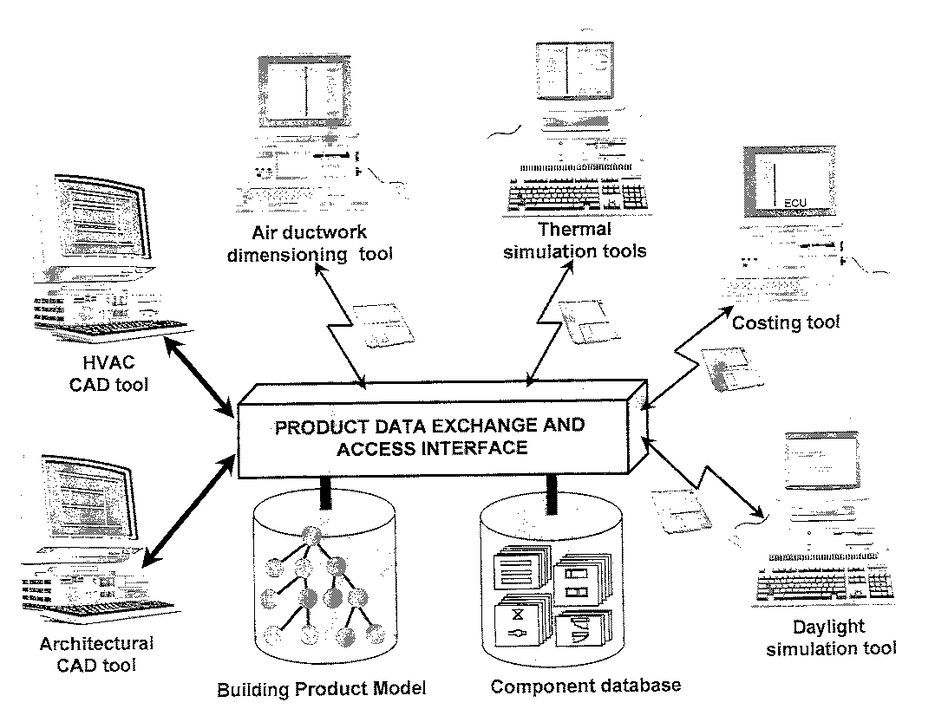
Figure 6. The basic idea of a building product model is to facilitate and automate the data transfer between different applications used in different design disciplines and project life cycle stages.
Building product modelling is a curious research domain since it is through standardisation that its results would have the biggest impact on practice. For this reason many of the leading researchers in this field have, in one way or the other, been involved in a large ISO standardisation activity called STEP (Standard for the exchange of product model data), which defines product model structures for all branches of industry [],[] . On the other hand there are also several researchers who seriously question the methodology used in STEP [], [].
The big difference compared to expert systems research is in the economic potential of product model techniques. Good robust product models, or even limited aspect models or application protocols for domains such as HVAC-systems or structural engineering, can still be useful for the exchange and sharing of data between dozens of specific applications. Recently, there has been an upsurge in the commercial interest for building product modelling, through an initiative by several large end users of commercial CAD systems to start to define the object classes needed in building product modelling (Industry Foundation Classes []).

Implementing the tools and standards in practice - IT strategy research
The way in which firms in the construction sector introduce and use IT offers an interesting field for empirical research. This research tries to answer two questions: what companies actually do and what they should do to get maximum benefits from their IT use. This domain obviously falls in a no man’s land between such disciplines as management studies, building economics and ITC. Methods typically used are individual case studies or bench-marking studies comparing the performance of different companies (for good examples c.f. []). This research is now getting increasing attention since more and more companies in construction are embarking on ambitious business process re-engineering attempts, rather than leaving their IT-policies to junior executives or IT-enthusiasts on the shop-floor level.
Nevertheless, the domain still needs quite a lot of methodological development; for instance which aspects of the IT use to study, how to measure the degree or efficiency of IT-use etc. As an example consider the use of CAD-systems. Is it the number of employees per workstation, the percentage of all drawings which are produced using CAD or the total cost of design work compared to the earlier manual process which is the best parameter of interest? All in all the human aspects of IT are of particular interest; how to organise training, re-engineering company procedures, how to motivate people to use IT-tools that sometimes offer more down-stream benefits than direct benefits to the immediate information producers.

Methodology issues

Different types of ITC research require different scientific methodologies
The methodological issues of ITC research have not been widely discussed in the published literature. Examples of authors discussing such issues include Crook et al. [].
One of the problems with applying standard scientific methods to ITC research is that ITC usually is concerned with the development of tools which change reality rather than with studying reality as it is, without influencing it. Another problem is related to the scale of the systems and tests needed to properly prove some hypotheses concerning re-engineering effects of particular categories of IT tools.
Of the three research fields presented above expert systems and IT-strategies seem, by their very nature, to be fields where it would be relatively straight-forward to apply standard scientific techniques. Expert systems, for instance, often require a rather limited set of input data and often offer only one proposed solution. It is therefore relatively easy to set up rigorous experiments where the performance of expert systems is compared to the performance of human experts, using data from several real life cases. Similarly it should be straightforward to apply standard sampling and interviewing techniques, as used in many social sciences, to IT strategy research aimed at describing how things are in industry. Proving hypotheses related to how things ought to be in industry is much more difficult, and often individual case studies and examples from other industries are used.
From a methodological viewpoint product modelling seems to offer a much more difficult challenge than the two other fields discussed above. For this reason and because of the author’s previous research experience with product modelling the rest of this methodological discussion is confined to the product modelling domain.

Methodological problems of product model research
Product model based applications are highly complex, involving data exchange between several different types of IT applications, implying that full-scale testing is costly and difficult. In addition the potential benefits of product modelling depend on economies of scale (i.e. through standardisation), making testing even more difficult. One author who has discussed the types of evidence provided by researchers developing product model based IT-tools is Clayton [].
In this author’s experience typical weaknesses, from a scientific viewpoint, of many reported product modelling research projects have been:
- The models are not developed or documented precisely enough to enable other researchers to evaluate or reuse them in their own work.
- Shortcuts are taken in the development of prototypes, which prevent comprehensive testing of the models. This may be due to restrictions in the software used (i.e. using commercial CAD-systems or relational data bases) or lack of resources for prototype development.
- Testing is done with very limited data (only a few classes and few instances of each class). Few research prototypes which have been tested with complete data for a whole building have been reported.
- The testing of prototypes is done by the same researchers who have developed the models and the prototypes. Ideally testing should be done by neutral third parties, for instance practitioners.
- The same downstream applications which, in the definition of the product model, were used to define the requirements for data structures, are also used for testing the resulting model. Ideally other applications in the same domain should be used.
- Testing of the prototype (and thus model) in a real design and construction process is only done as a dry run exercise in laboratory conditions.
- The evaluation of the use of the prototypes is not carried out and documented in a systematic way (for instance, measuring time used for different operations, using questionnaires to independent testers, checking that downstream applications get all their input data). Often the evidence is limited to the researchers own superficial perception of how the prototype seems to be performing (“the prototype proved that, showed that”).
- If the model and prototypes are tested in real project work this is done once only. Thus it is very difficult to determine how much the results are disturbed by the fact that the users are at the same time trying to learn to use new software tools, that the project in question may be particularly complicated etc.
- There are no parallel projects, where the same or similar buildings are being designed and constructed also using more traditional IT-tools, and where the same factors are being systematically studied, enabling a comparison of the effects of the product model on the process.
The consequence is that almost as a rule the usefulness of a particular model is not proven anywhere near scientifically. This author willingly confesses to having committed most of the “sins” listed above at one time or the other in his own earlier research work. Avoiding all of these traps would in fact be extremely difficult. At the same time researchers should be aware of these methodological issues and make conscious decisions about how the research is set up and discuss the choices they make openly as they present their results to the academic community.
The potential benefits of product models will mostly result from industry-wide standardisation, but such standardisation takes years to achieve and is beyond the control of individual researchers. Thus, it is next to impossible to study the overall effects of product models in an individual research project before product model tools and standards are used in at least a part of the industry, thus eventually enabling empirical studies comparing the information management efficiency in projects using and not using the technology. Developments in both commercial CAD systems and standardisation (STEP building construction application protocols and IFC development) may, in the near future, provide opportunities for researchers to do testing of product models in real projects.
Should researchers in the domain thus just accept the prevailing situation or can something be done? One of the first steps would be to develop further criteria related to the problems listed above, which are tailor-made for research involving the development of innovative IT tools which have effects on current information processes in construction.

Conclusions
This author believes there is a need for a discussion of ITC as a discipline, possibly leading to some degree of consensus among leading researchers on the scope and scientific methodology of the discipline. The author hopes that this paper could function as an input to such a discussion, which could be carried out through cross-referencing journal articles and conference papers, email conferences etc. The results would be helpful in training of researchers, in the planning of R&D programmes, in the development of taxonomies and definitions of central concepts, in presenting the subject in paper-based or web textbooks.
This paper has in particular stressed the following points:
- An abstract formalised model of information management in construction is proposed as the basis for a definition of the domain and boundaries of ITC.
- The use of car manufacturing (or the manufacturing industry in general) for bench-marking the effects of IT on the overall construction process is questioned. Healthcare is offered as an interesting domain offering many commonalities with the construction industry.
- There is a need for clarifying methodological issues related to many of the branches of ITC research. In particular this concerns the development and testing of new types of IT tools offering potential process reengineering benefits, such as product model based applications.
Finally the author wishes to stress that this article, by its nature and genesis, falls into a category somewhere in-between a basic textbook, a key-note lecture and a state-of-the art review. A large part of the subject matter consists of personal ideas and opinions, which have not been verified through systematic empirical investigation or the development and testing of prototypes, and cannot thus claim to add to the scientific knowledge of our domain. The value of a paper of this kind, if any, is more in providing impulses for a discussion of some rather fundamental issues in our research discipline.

Acknowledgements
The ideas presented in this article have evolved slowly over the past few years, in particular influenced by a need to teach this subject to fourth year civil engineering students at the Royal Institute of Technology. Some of the issues have been discussed in earlier presentations including a keynote lecture at the CIB W65 conference in Glasgow [] and the CIB W78 conference in Cairns [¹³]. Several colleagues have given valuable comments, in particular Ziga Turk, from the University of Ljubljana. This type of article has obviously been influenced by a huge amount of material published over the past two decades. For practical reasons references have, nevertheless, been kept at a minimal level.

References

 For reasons of convenience the abbreviation ITC will be used in this text whenever appropriate in stead of “information technology in construction”. Readers should note that this is done for readability reasons alone and not based on any common use of such an abbreviation.
Fenves, S. J.: The Penetration of Information Technologies into Civil and Structural Engineering Design: State-of-the-art and Directions Towards the Future, Keynote lecture, In: Kumar, B. and Retik. A. edts. Information Representation and Delivery in Civil and Structural Engineering Design, Civil-Comp Press, Galashiels, Scotland, 1996, pp. 1-5.
Brandon, P.; Smith, S.; Betts, M.: Creating a framework for IT in construction, paper presented at the Global IT construction Futures International meeting Armathwaite Hall, Lake District, UK, 1997. http://www.surveying.salford.ac.uk/meeting/docs/Abstarcts.htm
The SCENIC research and development database, Support CEntres Network for Information technology in Construction (SCENIC), http://scenic.fagg.uni-lj.si/
Journal of Computing in Civil Engineering, American Society of Civil Engineers, homepage: http://www.wmich.edu/jcce/home.htm
Automation in Construction, Elsevier Science, homepage: http://www.elsevier.nl/inca/publications/store/5/2/3/1/1/2/
International Journal of Construction Information Technology, University of Salford, homepage: http://www.salford.ac.uk/survey/ijcit/homepage.html
Electronic Journal of Information Technology in Construction, Royal Institute of Technology (Stockholm), homepage: http://itcon.org/
The International Journal of Computer-Integrated Design and Construction (CIDAC), Chapman & Hall, homepage: http://www.chapmanhall.com/id/idtext.htm
IDEF0 Function Modeling Method, Knowledge based systems Inc. (KBSI), Austin, Texas, 1997, http://www.idef.com/idef0.htm
Sanvido, V.: An Integrated Building Process Model, Computer Integrated Construction Research Program, Dept. of Architectural Engineering, Pennsylvania State University, USA, Technical Report No. 1.1990.
Cooper, R. et Al.: Process protocol - the development of a generic design & construction process protocol. Information material on the web, University of Salford. 1996. http://www.salford.ac.uk/survey/gdcpp/
Tolman, F.: Some integration reqirements for computer integrated building. In: Preproceedings of the CIB W78 seminar The Computer Integrated Future, Eindhoven University of Technology, ,the Netherlands, 1991
Björk, B.-C. INFOMATE: A framework for discussing information technology applications in construction, keynote lecture, In: Drogemuller, R. edt. Information Technology Support for Construction Process Re-Engineering IT-CPR-97, CIB W78 Workshop, Cairns 9 - 11 July 1997.
Turk, Z.: A Framework for the Engineering Information Technologies. Paper presented at the international conference on concurrent enterprises, University of Nottingham, 8-10 Oct 1997, http://www.fagg.uni-lj.si/~zturk/papers/nottingham.97/
Home page of the International Medical Informatics Society http://www.imia.org/ 97
Black, G.: Elusive electronic goal. Financial Times Review, 5.2.1997, p. 4
Nairn, G.: A vision for linking ”islands of technology”, Financial Times Review, 5.2.1997, p. 4
Blackmore J., Leong F., Sharpe, R., Williams P., CSIRO - Building the Future Down Under, In proceedings of the CIB W78 workshop Computers and Information Technology in Construction, National Research Council of Canada, Ottawa, 1993
Owen, J.: STEP, an introduction. Information Geometers, Winchester, England, 1993.
The SC4 On-Line Information Service (SOLIS), National Institute of Standards and Technology, Washington D. C., http://www.nist.gov/sc4/www/
Eastman, C. and Fereshetian, N. 1994. Information models for use in product design: a comparison. Computer-Aided Design, Vol. 26, no. 7, pp. 551-572.
Galle, P.: Towards integrated, intelligent, and compliant computer modeling of buildings Automation in Construction, Vol. 4, no. 3, 1995, pp.189-211
International Alliance of Interoperability (IAI), homepage: http://www.interoperability.com/
Best Practice Reports, Construct IT Centre of excellence, http://www.salford.ac.uk/survey/centex/#reports
Crook, D.; Rooke, J.; Seymour, D.: Research Techniques in Construction Information Technology, In: Turk, Z. (edt); Construction on the Information Highway, Proceedings of the CIB W78 Workshop, Bled, Slovenia, 10-12.6.1996. pp. 133-144.
Clayton, M. J.; Fisher, M.; Teicholz, P. and Kunz, J.: Charette Testing Method. Working Paper, CIFE, Stanford, 1996. http://tamu.edu/~mclay/mjc/mjc-arcc.htm
Björk, B.-C.: Information Technology in Construction. Keynote lecture at: International conference on information technology in civil and structural engineering design - taking stock and future directions, organised by CIB W65, Glasgow, 14-16.8. 1996

